Project Proposal

#### Project Name:

Ænigma

#### Project Author:

Dan Cassidy

#### Project Purpose:

This application will be able to use the Enigma cipher, developed by the Germans in the early 1920’s, to encode and decode local messages. The goal is to be able to mimic the machine settings perfectly, including different numbers & types of rotors and a different reflector.

#### Draft GUI Design:

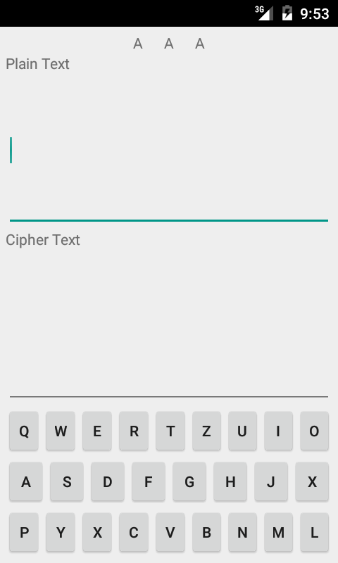

#### Major Techniques:

* MVC/MVP pattern of development. (Resources: Google, StackOverflow)
* Preference utilization. (Resources: Google, StackOverflow, Android Developer Website)
* Copy/Paste. (Resources: Google, StackOverflow, Android Developer Website)
* Menu Usage for Settings. (Resources: Google, StackOverflow, Android Developer Website)
* Fragments?

#### Work Plan:

* Complete the core classes.
* Create functional UI.
* Testing.
* Fix bugs.
* Refine UI.
* Repeat this section as necessary.

#### Comparison with Similar Apps:

Enigma Simulator by Frank Heath Ltd: An actual simulator for using an Enigma machine. This app appears to be very fancy and has settings file loading and saving, along with actually mimicking the Enigma machine layout.

Enigma by Allan Rempel: A modest application that appears to do what it says and nothing more.

Enigma NDS by Mincemeat TEAM: Apparently doesn’t work all that well, and looks fairly rough as well.

Enigma Code by Zabrsa: A simplistic Enigma cipher program that doesn’t appear to adequately represent how the original machines worked.